**Unit 3 Assignment Instructions – CIS164** 

*For the Unit 3 Assignment we will be working with the ability to control the flow of your code. This allows you to have the ability to make decisions based on input and output within your code. There may be times that you will want your programs to output something specific at one time and something different at another time, with the ability to make decisions within your code you can do just that!*

*Please make sure to fully read each question to ensure that you answer each question per the requirement. Also, please ensure that all responses are in complete sentences, free of spelling and grammatical errors.*

**\*Unit 3 Grading Rubric (45 Points):**

|  |  |  |
| --- | --- | --- |
| **Assignment Requirements** | **Maximum Points** | **Points Earned** |
| 1. Python Relational Operators | **0-10 Points** |  |
| 2. Comparisons (Flow Control) | **0-15 Points** |  |
| 3. Multiple Decisions | **0-20 Points** |  |
| **Points Deducted for Spelling or Grammatical Errors** | |  |
| **Total (Sum of All Points)** | |  |

**\*Directions for Submitting Your Assignment:**

Complete your assignment ensuring all questions are answered based on the assignment requirements. When the Unit 3 assignment is complete, please save your file in the following format, *“Lastname-Unit#.doc”* (Example: **Smith-Unit3.doc**). You may also utilize a Word Processing software such as LibreOffice for assignment completion. In this case the assignment may be saved in .odt format, (Example: **Smith-Unit3.odt**). Then when ready submit your file to the “**CIS 164 – Unit 3 Submit Assignment**” activity for grading.

**1. Python Relational Operators**

1. In Python what comparison operator stands for “Equal to”?

The “==” comparison operator returns true if the comparisons are equal.

1. In Python what comparison operator stands for “Not equal to”?

The “!=” comparison operator returns true if the comparisons are not equal.

**2. Comparisons (Flow Control)**

1. Start the PyCharm IDE. Select “File->New Project” on the next screen. Under “Location” change the word “untitled” to “Unit3”. Then click the “Create” button.
2. Highlight your project “Unit3” then right click. When you right click a menu will appear, from this menu select New->Python File. Then a dialog box will appear, in the “Name” field of the dialog box type “SimpleComparison.py”.
3. Within your SimpleComparison.py file, import the ‘random’ module to generate a random number between 1 and 10.
4. Next you will utilize what you have learned within the flow control chapter in our book to have a user guess the random number that is created. The script will need to output to the user when they have guessed the number incorrectly, as well as output to the user to congratulate them when they have guessed the number correctly.
5. For your script, you will need to provide a screenshot showing your completed script, as well as submit it in a text file, along with this document.

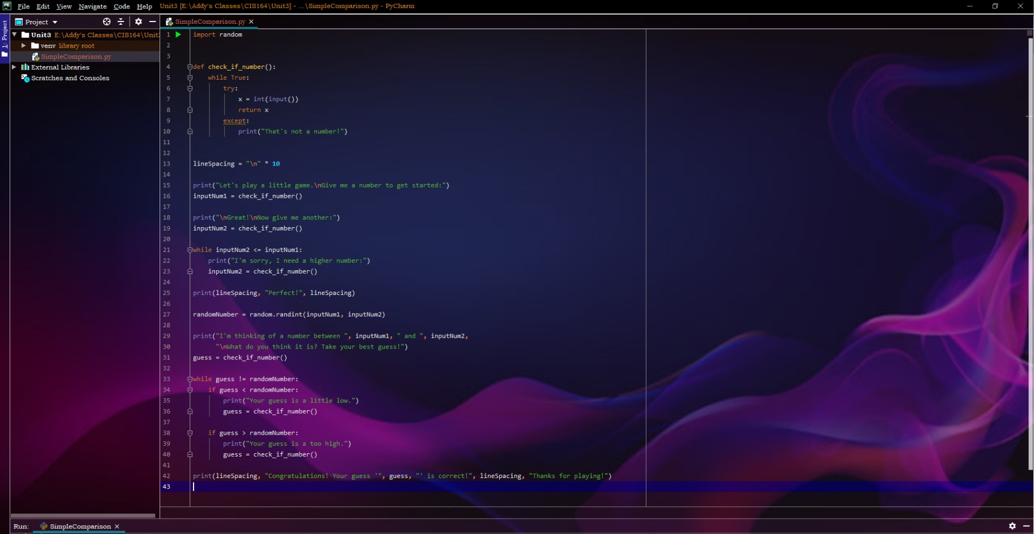**For this script I changed the random number range from 1-10 to instead the user’s two numbers they input. So it can be any integer, and the second guess will need to be higher than the first.**

**3. Multiple Decisions**

1. Highlight your project “Unit3” then right click. When you right click a menu will appear, from this menu select New->Python File. Then a dialog box will appear, in the “Name” field of the dialog box type “MultipleComparisons.py”.
2. Within your MultipleComparisons.py file, ask for input from a user to have them enter their name. Then within your Python script check to see if the input from the user is equal to the name “Bob”, if the user does not enter the name “Bob” then return, “Your name is not Bob go away!”

Else if the user does enter the name “Bob” you will then ask the user to input their password. If their password does not equal “pass123” then you will return, “You have entered the wrong password, go away!” {**Note: there are certainly much better ways to take password input from a user, but we can cover that at a later time!}

Else if they do enter the correct password, then you will return to the user, “User Bob, your access has been granted, enjoy your day!”

1. 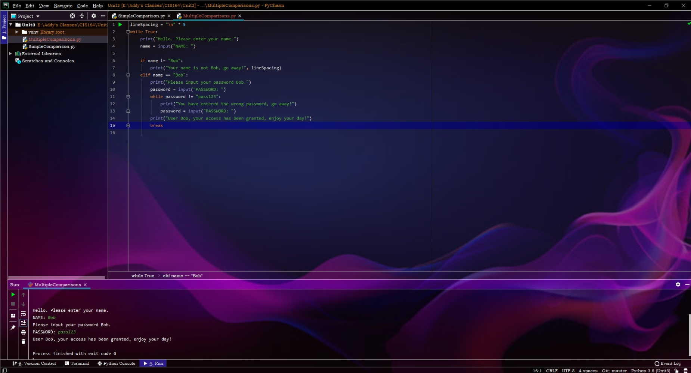For your script, you will need to provide a screenshot showing your completed script, as well as submit it in a text file, along with this document.